**Hopping into spring!**

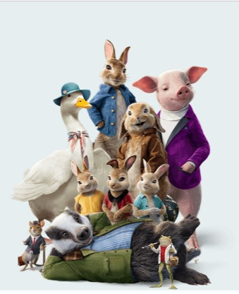

**Peter Rabbit Themed Egg Hunt**

**Spring is a season to be celebrated. When we imagine winter, often roaring fires, chunky knits and cosy surroundings are put forward. The reality, especially if you have animals is prevailing winds, cruel coldness and chasing the daylight...... however that is all about to change!! So why not embrace the warmth of the sun, dust off your welly boots for a family pursuit at the riding school!! Combine exercise and chocolate (that is our kind of fitness)**

**Easter Egg Hunt on Good Friday 30th March.**

**10:30am-12:30pm.**

**£5 per person. Book in the office TODAY.**

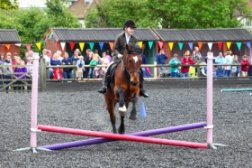

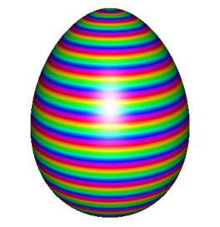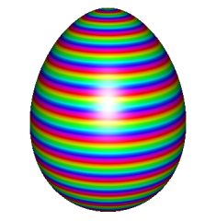

**Future Events**

**........ Keep up to date by using our Events Calendar at www.horseshoesridingschool.co.uk**

* **Tetrathlon Challenge**
* **Own A Pony Easter Holidays 3rd-13th April 2018.**
* **Jumping Workshops**
* **Introduction to Cross Country Clinic**
* **Pony Club Mounted Games Day**

**Get more involved in horses. Why not join....**

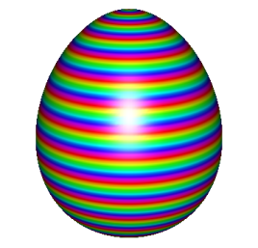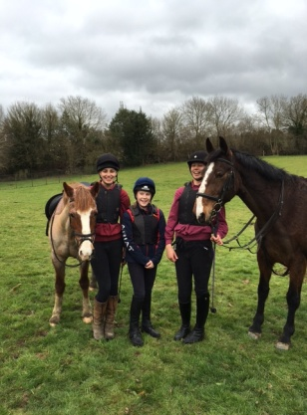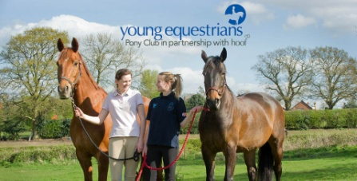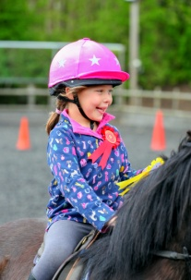

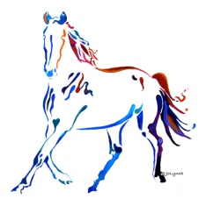

***Riding Club***